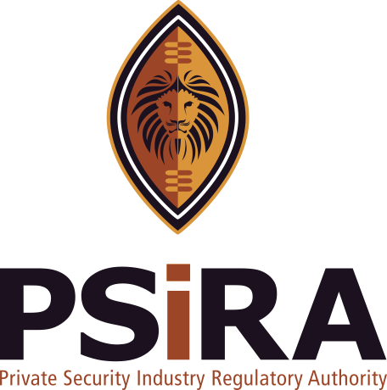
THE DIRECTOR
PRIVATE SECURITY INDUSTRY REGULATORY AUTHORITY

PRIVATE BAG X817
PRETORIA
0001

 :(012) 337 5500
FAX :(012) 324 6225
 (012) 337 5500
FAX (012) 324 6225
http://www.sira-sa.co.za

Private Security Industry Regulatory Authority (SIRA)

[SIRA-38 N.I.T.]

http://www.sira-sa.co.za

Inspection Number :

TRAINING ESTABLISHMENT INSPECTION REPORT
Inspection Report for the evaluation of a Training Establishment.

Inspection Date |  |  |  |  |  |  |  |  |  | T-Number
Duration of Inspection |  |  |  |  | Start |  |  |  | h |  |  | End |  |  |  |  | h
Name of Inspector |  |  |  |  |  |  |  |  |  | Contact Number
Name of Business |  |  |  |  |  |  |  |  |  |  |  |  | SIRA Number
Street Address
Suburb |  |  |  |  |  |  |  |  |  |  |  |  | Street Code
Postal Address
Suburb |  |  |  |  |  |  |  |  |  |  |  |  | Postal Code
E-Mail address (if available)
CLOSE CORPORATION |  |  | BUSINESS REGISTRATION NUMBER
Telephone |  |  |  | Fax |  |  |  |  |  |  |  | Cell Phone
Validated particulars including Name, Address and Contact Numbers |  |  |  |  |  |  |  |  |  |  |  |  |  |  |  | YES
Name of Person Interviewed |  |  |  |  |  |  |  |  |  |  | Position

1. Instructors |  |  |  |  |  |  | SIRA Number |  | Instructor Grade
1.
2.
3.
4.
5.
6.

2. Grading
Grade E |  | X | Grade D |  |  |  | X | Grade C |  | X
Grade B |  | X | Grade A |  |  |  | X | Grade E-C Bridging
Armed Response |  |  | Firearms Instructor |  |  |  |  | Special Events
Banking |  |  | Retail |  |  |  |  | Cash-In-Transit
Other Grade
3. Classrooms |  |  |  | Accredited | In Use | Comments
Number of Classrooms
Students / Classroom 1
Students / Classroom 2
Students / Classroom 3
Students / Classroom 4
Students / Classroom 5
Students / Classroom 6

4. Classroom Detail
Chairs/Tables |  | YES |  | Safety Signs | YES
White Board |  | YES |  | Fire Extinguisher | YES
Flip Chart |  | YES |  | Iron/Ironing Board | YES
Overhead Projector |  |  |  | Overhead Projector Screen | NO
Batons |  | YES |  | Student Manuals | YES
Radios |  | YES |  | Locked Cabinet | YES
Transparencies |  | YES |  | Lesson Plans | YES
Practice Pro Formas |  | YES

5. Practical Area
Entrance Access
Surface
Practical Evaluation

6. Administration

Course:
Comments/Notes from the Inspector:

Course:
Comments/Notes from the Inspector:

Course:
Comments/Notes from the Inspector:
Course Reports sent to SIRA within 14 days (Are Course reports submitted timeously) |  |  |  |  | YES

Seven-day notice to be Authorized in terms of Training Regulations 18(2) or 21(2)
Annual Fees  (including interest & penalties, if any) |  |  | R | 00.00
Annual Fees Collected |  |  | R | 00.00
Outstanding Fines |  |  | R | 00.00
Outstanding R/D Cheques |  |  | R | 00.00

7. Comments

8. | DIRECTIVES

The following directives are hereby issued by the inspector in terms of Section 34 of the Private Security Industry Regulation Act, 2001 (Act 56 of 2001). Failure to adhere to these directives constitutes a criminal offence and a contravention of the Code of Conduct for Security Service Providers, 2003.

You are hereby directed to submit (produce) the following documents / objects to :
 | Inspector:
 | At:
 | Or alternatively with prior arrangement, at/to:
 | Before or on the following date:

To wit:

9. | RECEIPT

Receipt issued in terms of Section 34 of the Private Security Industry Regulation Act, 2001 (Act 56 of 2001) for original documents /objects seized/received:
(Note: receipt issued for copies are merely for record purposes)

To wit:

NOTES TO ACCOUNT ADMINISTRATOR

IMPORTANT

IMPROPER CONDUCT BY A SECURITY SERVICE PROVIDER

A security service provider who -
(a) | contravenes or fails to comply with a provision of the Act;
(b) | commits an offence contemplated in the Schedule to the Act;
(c) | contravenes or fails to comply with a provision of the Levies Act; or
(d) | contravenes or fails to comply with a provision of the Code of Conduct,

Is guilty of improper conduct and on conviction liable to the following penalties -
(a) | a warning or a reprimand;
(b) | suspension of registration as security service provider for a period not exceeding 12 months;
(c) | withdrawal of registration as security service provider;
(cA) | withdrawal as accredited training establishment;
(d) | a fine not exceeding R1 000 000-00, which is payable to the Authority;
(e) | publication of appropriate details of the conviction of improper conduct and any penalty imposed;
(f) | endorsement against the register of SSP’s any certificate of registration or other documentation
 | issued by the Authority, of the conviction of improper conduct and any penalty imposed; or
(g) | any combination of the above.

